Comfort your family in their loss and sorrow.
Be our refuge and our strength, O Lord
Prayer for Mourners

This is a sad time for you and your family. It is hard to lose someone we love. The people of this parish community wish to support and console you in your loss. As you grieve and cope with your loss, we wish to assure you of our prayerful support during this time.

The ministry of the priest at the time of a funeral is one aspect of our parish community’s support for you. He is there to spend time with you and your family; to support you and also to assist you in preparing for the funeral; in leading times of prayer; and in presiding at the funeral mass.

You will mourn and remember your loved one in different ways – you will have your own quiet private moments, but there will also be more public times for you, as you accompany the body of your loved one from their place of death to their final place of rest.
***
At the Reception of the Body at the Church, usually on the evening before the Funeral Mass, you will encounter some of the symbols of our faith, which remind us what we believe about life and death. On arrival at the Church door the body of the deceased is sprinkled with holy water. As family members or friends of the dead person,
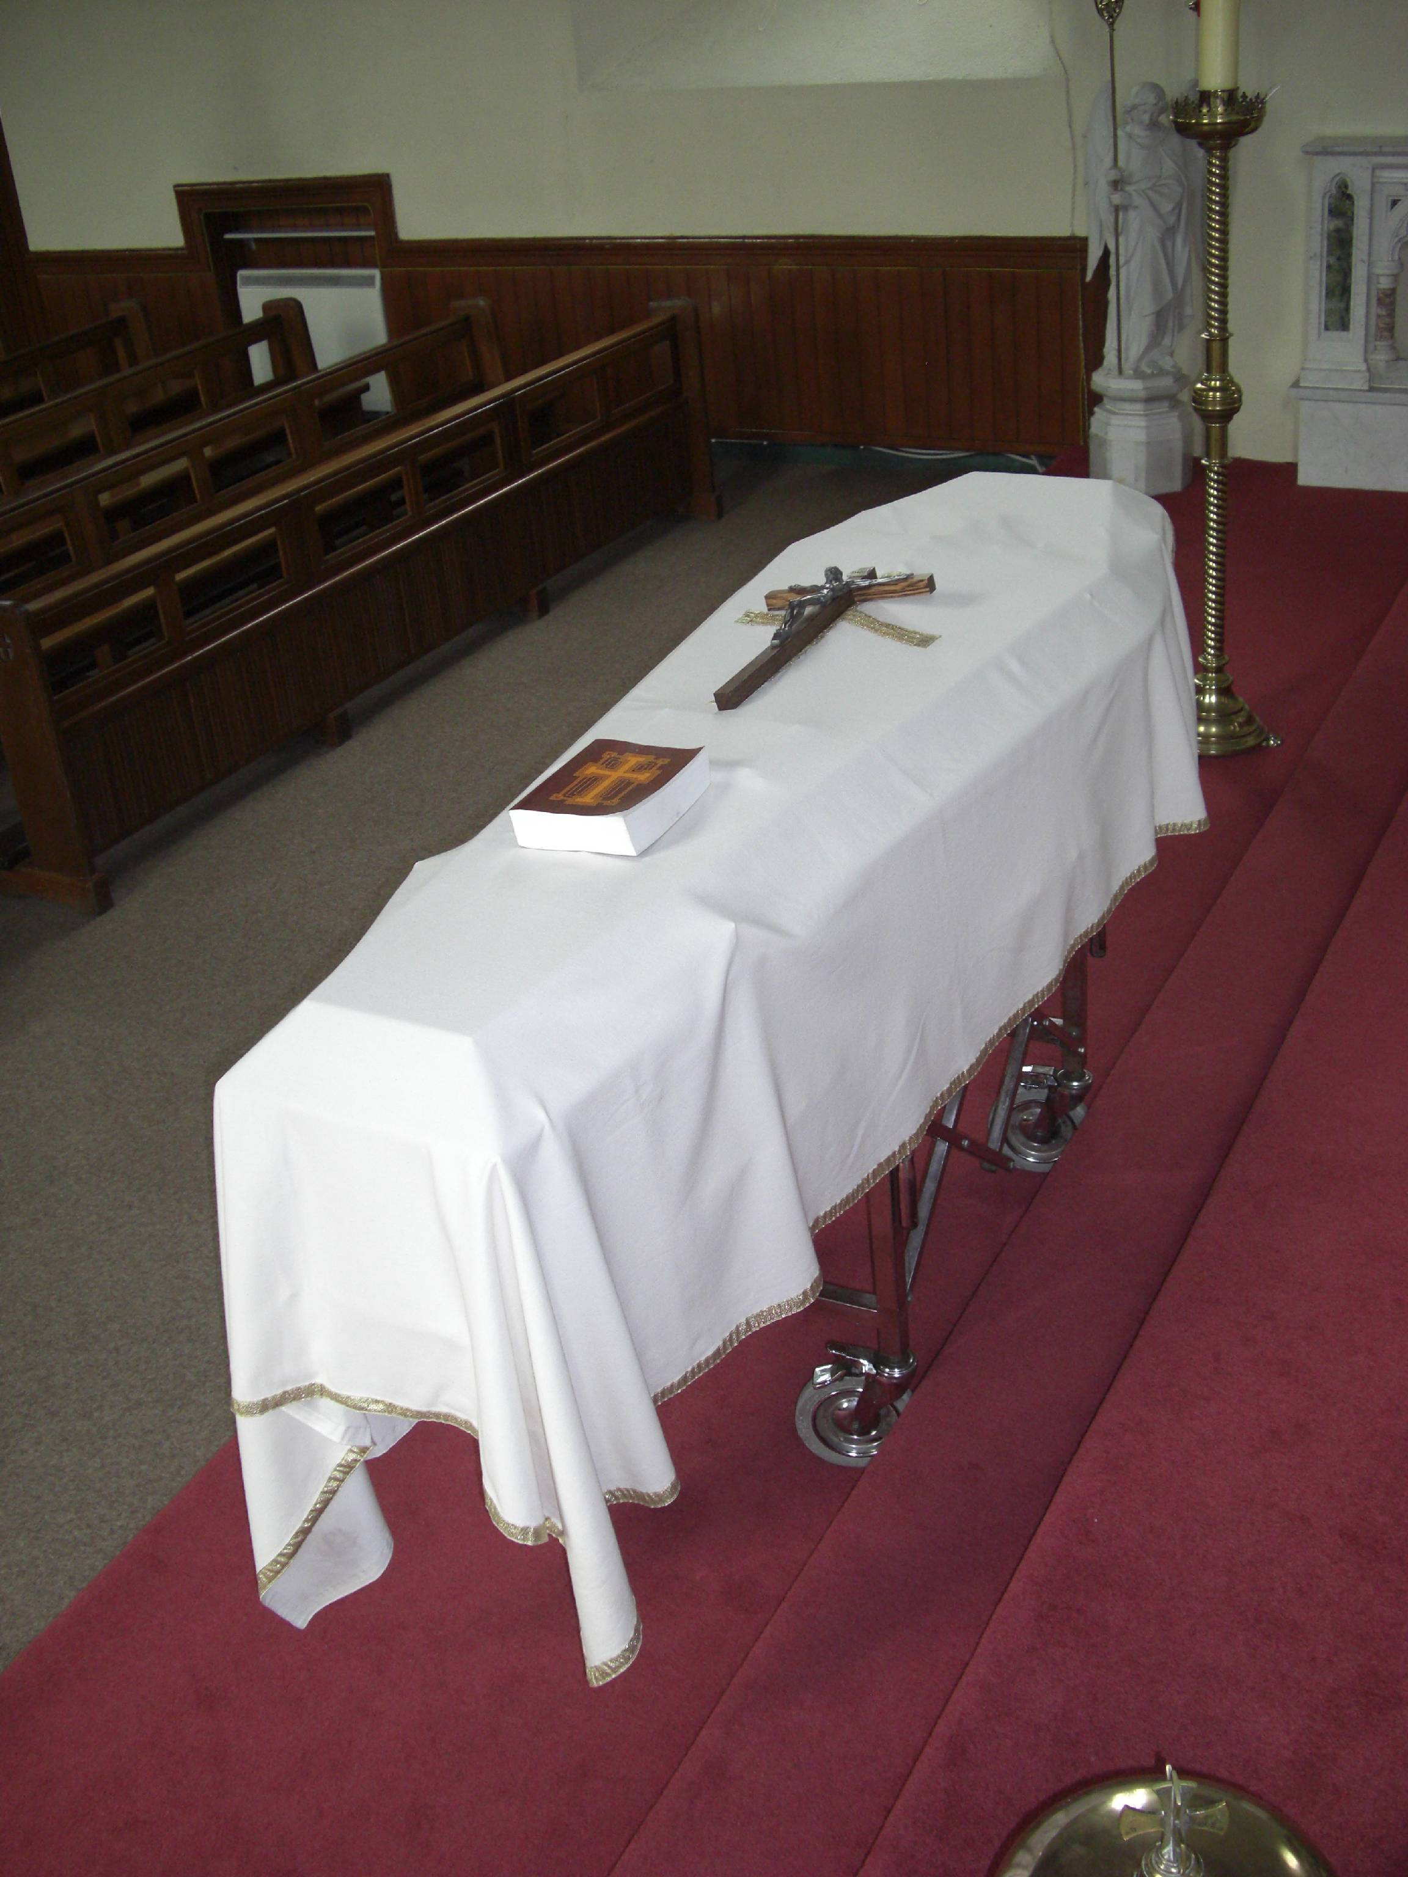
you may be invited to place the pall over the coffin.
If a flag or other insignia had been draped over the
coffin, it has already been removed as the coffin is
brought into the church. The pall is a large, white
cloth that covers the coffin completely. It is simple
in design and unadorned and recalls the white
baptismal garment. It reminds us that we are all
equal in the sight of God.

We place on the coffin symbols of our hope:
A Cross , in baptism we were traced with the sign of the cross, during life we signed ourselves with the sign of the cross, and now at death, we share in Christ’s victory over death.

A book of the Gospels or a Bible may be placed on the coffin as a sign that Christians live by the word of God.


The Paschal Candle will be placed near the
coffin during the funeral liturgies.
It is symbolic of ‘Christ our Light’
present among us, and his
victory over death.

***
At the Funeral Mass, we gather as a community to pray for the one who has died, to comfort and console those who are bereaved, and to proclaim our hope and our belief in Christ’s victory over death.

The Word of God offers us life and hope, and in this booklet you will find a selection of the Sacred Scripture provided for funerals. This is to give you and us, the family and the community, an opportunity to hear God speak to our needs, sorrows, fears and hopes, as we mourn your loved one.

In the Prayer of the Faithful, we, the Christian community, call upon God to comfort the bereaved and to show mercy to the deceased. A selection of prayers of intercession is presented in this booklet. You might wish to adapt theses prayers and this can be discussed with your priest as you prepare for the funeral Mass.
At the beginning of the Liturgy of the Eucharist, the gifts of bread and wine are offered. They are transformed to become the body and blood of Jesus Christ. These gifts may be brought to the altar by family members or by members of the wider community.

For the Final Commendation at the end of the funeral Mass, the book of the Gospels or Bible, the cross and the pall are removed from the coffin. Again members of your family or friends may wish to do this, or members of the parish community will be glad to assist.

The coffin is sprinkled with holy water. Through the sprinkling, we recall that in baptism each of us was marked for the fullness of eternal life.


Incense is used during the Final Commendation
to honour the body of the deceased,
because in baptism, this person’s
body became a temple
of the Holy Spirit.

* * *



Mass 1

A reading from the book of Wisdom 3:1-6, 9

The souls of the virtuous are in the hands of God,
no torment shall ever touch them.
In the eyes of the unwise, they did appear to die,
their going looked like a disaster,
their leaving us like an annihilation;
but they are in peace.
If they experience punishment as others see it,
their hope was rich with immortality;
slight was their affliction, great will their blessing be.
God has put them to the test
and proved them worthy to be with him;
he has tested them like gold in a furnace,
and accepted them as a holocaust.
They who trust in him will understand the truth,
those who are faithful will live with him in love;
for grace and mercy await those he has chosen.
The word of the Lord.

Psalm 114
R/ I will walk in the presence of the Lord in the land of the living

- How gracious is the Lord, and just;
our God has compassion.
The Lord protects the simple hearts;
I was helpless to be saved.

- I trusted, even when I said:
‘I am solely afflicted,’
And when I said in my alarm:
‘No man can be trusted’.

- O precious in the eyes of the Lord
is the death of his faithful.
Your servant, Lord, your servant am I;
you have loosened my bonds.

A reading from the letter of St. Paul to the Romans 14:7-12

The life and death of each of us has its influence on others,
if we live, we live for the Lord;
and if we die, we die for the Lord,
so that alive or dead we belong to the Lord.
This explains why Christ both died and came to life,
it was so that he might be Lord both of the dead and of the living.
We shall all have to stand before the judgment seat of God;
as scripture says: By my life it is the Lord who speaks – every knee shall bend before me, and every tongue shall praise God.
It is to God, therefore, that each of us must give an account of themselves.
The word of the Lord


Mass 2

A reading from the book of Job 19:1, 23-27

Job said:
‘Ah, would that these words of mine were written down,
inscribed on some monument
with iron and chisel and engraving tool,
cut into the rock forever.
This I know: that my Avenger lives,
and he, the Last, will take his stand on earth.
After my awakening, he will set me close to him,
and from my flesh I shall look on God.
He whom I shall see will take my part:
these eyes will gaze on him and find him not aloof.’
The word of the Lord

Psalm 26
R/ The Lord is my light and my help

- The Lord is my light and my help;
whom shall I fear?
The Lord is the stronghold of my life;
Before whom shall I shrink?

- There is one thing I ask of the Lord,
for this I long,
to live in the house of the Lord,
all the days of my life,
to savour the sweetness of the Lord,
to behold his temple.

- O Lord, hear my voice when I call;
have mercy and answer.
It is your face, O Lord, that I seek;
Hide not your face.

- I am sure I shall see the Lord’s goodness
in the land of the living.
Hope in him, hold firm and take heart.
Hope in the Lord.

A reading from the book of Revelation 14:13

I, John, heard a voice from heaven say to me,
‘Write down: Happy are those who die in the Lord!
Happy indeed, the Spirit says;

now they can rest for ever after their work,
since their good deeds go with them.’
The word of the Lord

Mass 3

A reading from the book of Lamentations 3:17-26

My soul is shut out from peace;
I have forgotten happiness.
And now I say; ‘My strength is gone,
that hope which came from the Lord.’
Brooding on my anguish and affliction
is gall and wormwood.
My spirit ponders it continually
and sinks within me.
This is what I shall tell my heart,
and so recover hope:
the favours of the Lord are not all past,
his kindnesses are not exhausted;
every morning they are all renewed;
great is his faithfulness.
‘My portion is the Lord’ says my soul,
‘and so I will hope in him.’
The Lord is good to those who trust him,
to the soul that searches for him.
It is good to wait in silence for the Lord to save.
The word of the Lord

R/ To you, O Lord, I lift up my soul. Psalm 24

- Remember your mercy, Lord,
and the love you have shown of old.
In your love remember me,
because of your goodness, O Lord.

- Relieve the anguish of my heart
and set me free from my distress.
See my affliction and my toil
and take all my sins away.

- Preserve my life and rescue me.
Do not disappoint me, you are my refuge.
May innocence and uprightness protect me:
for my hope is in you, O Lord.

A reading from the letter of Saint Paul to the Romans 8:31-35, 37-39

With God on our side who can be against us? Since God did not spare his own Son, but gave him up to benefit us all, we may be certain, after such a gift, that he will not refuse anything he can give. Could anyone accuse those that God has chosen? When God acquits, could anyone condemn? Could Christ Jesus? No! He not only died for us – he rose from the dead, and there at God’s right hand he stands and pleads for us.

Nothing, therefore, can come between us and the love of Christ, even if we are troubled or worried, or being persecuted , or lacking food or clothes, or being threatened or even attacked. As scripture promised: For your sake we are being massacred daily, and reckoned as sheep for the slaughter. These are the trials through which we triumph, by the power of him who loved us.

For I am certain of this: neither death nor life, no angel, no prince, nothing that exists, nothing still to come, not any power, or height or depth, nor any created thing, can ever come between us and the love of God made visible in Christ Jesus our Lord.
The word of the Lord

Mass 4

A reading from the prophet Isaiah 25:6-9

On this mountain,
the Lord of hosts will prepare for all peoples
a banquet of rich food.
On this mountain he will remove
the mourning veil covering all peoples,
and the shroud enwrapping all nations,
he will destroy Death for ever.
The Lord will wipe away
the tears from every cheek;
he will take away his people’s shame
everywhere on earth,
for the Lord said so.
That day it will be said: See this is our God
in whom we hoped for salvation;
the Lord is the one in whom we hoped.
We exult and we rejoice
that he has saved us.
The word of the Lord.

Psalm 22
R/ The Lord is my shepherd; there is nothing I shall want.

- The Lord is my shepherd;
There is nothing I shall want.
Fresh and green are the pastures
where he gives me repose.
Near restful waters he leads me,
to revive my drooping spirit.

2. He guides me along the right path,
he is true to his name.
If I shall walk in the valley of darkness,
no evil would I fear.
You are there with your crook and your staff,
with these you give me comfort.

3. You have prepared a banquet for me
in the sight of my foes.
My head you have anointed with oil;
my cup is overflowing.

- Surely goodness and kindness shall follow me
all the days of my life.
In the Lord’s own house shall I dwell,
for ever and ever.

A reading from the first letter of St. John 3:1-2

Think of the love that the Father has lavished upon us,
by letting us be called God’s children;
and that is what we are.
Because the world refused to acknowledge him,
therefore it does not acknowledge us.
My dear people, we are already the children of God,
but what we are to be in the future has not yet been revealed;
all we know is, that when it is revealed,
we shall be like him,
because we shall see him as he really is.
The word of the Lord.

Mass 5

A reading from the Acts of the Apostles 10:34-36, 42-43

Peter addressed Cornelius and his household: ‘The truth I have now come to realise’, he said, ‘is that God does not have favourites, but that anybody of any nationality, who fears God and does what is right is acceptable to him.’
‘It is true, God sent his Word to the people of Israel, and it was to them that the good news of peace was brought by Jesus Christ – but Jesus Christ is Lord of all people and he has ordered us to proclaim this to his people and to tell them that God has appointed him to judge everyone, alive or dead. It is to him that all the prophets bear this witness: that all who believe in Jesus will have their sins forgiven through his name.
The word of the Lord.

Psalm 62
R/ For you my soul is thirsting, O Lord, my God.

- O God, you are my God, for you I long;
for my soul is thirsting.
My body pines for you
like a dry, weary land without water.

- So I gaze on you in the sanctuary
to see your strength and your glory.
For your love is better than life,
my lips will speak your praise.

- So I will bless you all my life,
in your name I will lift up my hands.
My soul shall be filled as with a banquet,
my mouth shall praise you with joy.

- You have been my help;
in the shadow of your wings I rejoice.
My soul clings to you;
your right hands holds me fast.

A reading from the first letter of Saint John 4:7-12, 17

My dear people,
let us love one another
since love comes from God,
and everyone who loves is begotten by God and knows God.

Anyone who fails to love can never have known God,
because God is love.
God’s love for us was revealed
when God sent into the world his only Son
so that we could have life through him:
this is the love I mean:
not our love for God,
but God’s love for us when he sent his Son
to be the sacrifice that takes our sins away.

We ourselves have known and put our faith in
God’s love towards ourselves.
God is love
and anyone who lives in love lives in God
and God lives in him.
The word of the Lord.
Mass 6
A reading from the first letter of St. Paul to the Thessalonians 4:13-18
We want you to be quite certain, brothers and sisters, about those who have died, to make sure that you do not grieve about them like the other people who have no hope. We believe that Jesus died and rose again, and that it will be the same for those that have died in Jesus: God will bring them with him. We can tell you this from the Lord’s own teaching, that any of us who are left alive until the Lord’s coming will not have any advantage over those who have died. At the trumpet of God, the voice of the archangel will call out the command and the Lord himself will come down from heaven; those who have died in Christ will be the first to rise, and then those of us who are still alive will be taken up in the clouds, together with them, to meet the Lord in the air. So we shall stay with the Lord forever. With such thoughts as these you should comfort one another. The word of the Lord.

R/ The Lord is my light and my help Psalm 26

- The Lord is my light and my help;
whom shall I fear?
The Lord is the stronghold of my life;
Before whom shall I shrink?

- There is one thing I ask of the Lord,
for this I long,
to live in the house of the Lord,
all the days of my life,
to savour the sweetness of the Lord,
to behold his temple

- O Lord, hear my voice when I call;
have mercy and answer.
It is your face, O Lord, that I seek;
Hide not your face.

- I am sure I shall see the Lord’s goodness
in the land of the living.
Hope in him, hold firm and take heart.
Hope in the Lord.

Mass 7
A reading from the letter of St. Paul to the Philippians 3:20-21
For us our homeland is in heaven, and from heaven comes the saviour we are waiting for, the Lord Jesus Christ, and he will transfigure these wretched bodies of ours into copies of his glorious body. He will do that by the same power with which he can subdue the whole universe.
The word of the Lord

R/ The Lord is my shepherd; there is nothing I shall want. Psalm 22

- The Lord is my shepherd;
There is nothing I shall want.
Fresh and green are the pastures
where he gives me repose.
Near restful waters he leads me,
to revive my drooping spirit.

2. He guides me along the right path,
he is true to his name.
If I shall walk in the valley of darkness,
no evil would I fear.
You are there with your crook and your staff,
with these you give me comfort.

3. You have prepared a banquet for me
in the sight of my foes.
My head you have anointed with oil;
my cup is overflowing.

4. Surely goodness and kindness shall follow me
all the days of my life.
In the Lord’s own house shall I dwell,
for ever and ever.
Additional Readings

A reading from the letter of St. Paul to the Romans 5: 5-11

Hope is not deceptive because the love of God has been poured into our hearts by the Holy Spirit which has been given us. We were still helpless when at the appointed moment Christ died for sinful people. It is not easy to die even for a good person – though of course for someone really worthy, someone might be prepared to die, but what proves that God loves us is that Christ died for us while we were still sinners. Having died to make us righteous, is it likely that he would now fail to save us from God’s anger? When we were reconciled, surely we may count on being reconciled by the life of his son? Not merely because we have been reconciled but because we are filled with joyful trust in God, through our Lord Jesus Christ, through whom we have already gained our reconciliation.
The word of the Lord.

A reading from the book of Isaiah 61 1-3

The Spirit of the Lord is upon me,
because the Lord has anointed me;
he has sent me to bring Good News to the oppressed,
to bind up the broken hearted,
to proclaim liberty to captives,
and release to prisoners;
to proclaim the year of the Lord’s favor,
and the day of vengeance for our God;
to comfort all who mourn;
to provide for those who mourn in Zion –
to give them a garland instead of ashes,
the oil of gladness instead of mourning,
the mantel of praise instead of a faint spirit.
They will be called oaks of righteousness,
the planting of the Lord to display his glory.
The word of the Lord

A reading from the book of Ecclesiastes 3: 1-8, 11

For everything there is a season,
and a time for every matter under heaven:
a time to be born, and a time to die;
a time to plant and a time to pluck up what is planted;
a time to kill and a time to heal;
a time to break down, and a time to build up;
a time to weep and a time to laugh;
a time to mourn and a time to dance;
a time to cast away stones, and a time to gather stones together;
a time to embrace, and a time to refrain from embracing;
a time to seek, and a time to lose;
a time to keep, and a time to cast away;
a time to rend, and a time to sew;
a time to keep silence, and a time to speak;
a time to love, and a time to hate;
a time for war and a time for peace.
God has made everything beautiful in its time.
The word of the Lord

Psalm 142
R/ Lord, listen to my prayer

- Lord, listen to my prayer:
turn your ear to my appeal.
You are faithful, you are just; give answer.
Do not call your servant to judgment
for no one is just in your sight.

- I remember the days that are past:
I ponder all your works.
I muse on what your hand has wrought
and to you I stretch out my hands.
Like a parched land my soul thirsts for you.

- Lord, make haste and give me answer:
for my spirit fails within me.
In the morning let me know your love
for I put my trust in you.

- Teach me to do your will
for you, O Lord, are my God.
Let your good spirit guide me
in ways that are level and smooth.


Gospel Acclamations

Alleluia, Alleluia!
‘Heaven and earth will pass away,
but my words will not pass away,’
says the Lord.
Alleluia!

Alleluia, Alleluia!
I am the light of the world.
Whoever follows me will never walk in darkness,
but will have the light of life says the Lord.
Alleluia!

Alleluia, Alleluia!
‘I am the resurrection and the life,
those who believe in me,
even though they die, will live,’
says the Lord.
Alleluia!

Alleluia, Alleluia!
‘Come to me all you that are weary
and are carrying heavy burdens,
and I will give you rest,’
says the Lord.
Alleluia!

Praise and glory to you, Lord Jesus Christ!
I have come that you may have life,
and have it more abundantly,’
says the Lord.
Praise and glory to you, Lord Jesus Christ!

Prayers of the Faithful 1

Priest: God, the almighty Father, raised Christ his Son from the dead;
with confidence we ask him to save all his people, living and dead:

- For __________ who ate the body of Christ, the bread of life, that she/he may be raised up on the last day. Lord hear us.

2. For the family and friends of __________ that they may be consoled in their grief by the Lord who wept at the depth of his friend Lazarus. Lord hear us.

3. For those who bear the cross of pain in mind or body. May they never feel forsaken by God. Lord hear us.

4. For all those assembled here to worship in faith, that we may be
gathered together again in God’s kingdom. Lord hear us.

5. For all those who have died. May God give them a place in the
kingdom of heaven. Lord hear us.

Priest: God of loving kindness, listen favorably to our prayers: strengthen our belief that your Son has risen from the dead and our hope that your servant __________ will also rise again. We ask this through Christ our Lord.

All: Amen

Prayer of the Faithful 2

Priest: Jesus is the Son of God and the pattern for our own creation.
His promise is that one day we shall truly be like him.
With our hope founded on that promise, we pray:

- That God will receive our praise and thanksgiving for the life
of __________. Lord hear us.

- That God will bring to completion __________’s baptism
into Christ. Lord hear us.

- That all of us, __________’s family and friends may be
comforted in our grief. Lord hear us.

- That god will grant release to those who suffer in mind or body.
Lord hear us.

- That God will grant peace to all who have died in the faith of Christ. Lord hear us.

Priest: Lord God you entrusted _________ to us and now you embrace her/him in your love.
Comfort us, your sorrowing servants, who seek to do your will and to know your saving peace. We ask this through Christ our Lord.

All: Amen
Prayers of the faithful 3

Priest: God, the almighty Father, raised Christ his Son from the dead;
with confidence we ask him to save all his people, living and dead:

- In Baptism __________ received the light of Christ. Scatter
the darkness now and lead her/him over the waters of death.
Lord hear us.

- The family and friends of __________ seek comfort and
consolation. Heal their pain and dispel the darkness and doubt
that come from grief. Lord hear us.

- For all of us assembled here to worship in faith, that we may
be gathered together again in God’s kingdom.
Lord hear us.

- For our deceased relatives and friends and for all who have
helped us, that they may have the reward of their goodness.
Lord hear us.

- For those who have fallen asleep in the hope of rising again,
that they may see God face to face. Lord hear us.

Priest: God, our shelter and our strength, you listen in love to the cry of your people: hear the prayers we offer for our departed brothers and sisters. Cleanse them of their sins and grant them the fullness of redemption.
We ask this through Christ our Lord.

All: Amen

Prayer of the Faithful 4

Priest: Surrounded by the sorrow of death, let us turn to Christ,
who alone has the words of eternal life:

- For __________ who has passed from this life, may she/he
now enjoy the lasting peace of heaven. Lord hear us.

- For __________’s family who are mourning at this time, that
in this time of sorrow and sadness, the Lord may be their
strength and consolation. Lord hear us.

- For those who may be worried or anxious at this time, that they
may trust in God to care for them in all their needs.
Lord hear us.

- For those whom we have been asked to pray for, that the Lord
may give them his joyful peace. Lord hear us.

- For the sick, those at home and in hospital, that they may find
strength in the power of the cross and find hope in their faith.
Lord hear us.

Priest: Father, your Son alone has the words of eternal life. He came that we might have life and have it to the full. Help us to listen to his voice, and to act on his words, so that we may come to the glory of your kingdom. Where he lives and reigns with you and the Holy Spirit, one God, for ever and ever.

All: Amen

At the time of bereavement, the care of family, friends and the local community can be a great help. Support is available from –
Fr Liam Tel 029 78096

I.R.D. Duhallow Bereavement Support 029 60633

Bereavement Counselling Service 01 839 1766

Irish Sudden Infant Death Association 1850 391391

The Miscarriage Association of Ireland 01 873 5702
01 872 5550

Living Links Kerry 087 0505660
Support service for families or individuals bereaved through suicide.
Samaritans Helpline: 1850 609090
Tralee: 066 7122566
Provides listening/befriending service 24 hours a day
365 days a year for those experiencing personal crisis.

Southwest Counselling Centre Killarney 064 6636416
General counselling service

Anam Cara 01 2958567
Parenal & Sibling Bereavement Support

Childline 1800 666666
Listening service for young people

Teentxt Text the word ‘teen’ to 50101
Teentxt can help if you are a young person stressed or worried……
This is a free text service to Teens & it is private and confidential.

